DESIGN AND IMPLEMENTATION OF 3D VISUALIZATION VIRTUAL WORLD LASER DIODE END PUMPED ND:YVO₄
¹Mohammed J. Abdulrazzaq, ²Raed K. Ibrahim, ¹Zaynab Q. Mohammed.
Zaynab Q. Mohammed¹, Mohammed J. Abdul-Razak¹ and Raed K. Ibrahim ²
¹Laser & Optoelectronics Engineering Department, University of Technology, Baghdad, Iraq

²Electrical Engineering Technical College????

Contact: zaynab.qassim@yahoo.com
ABSTRACT:In this paper virtual-reality (VR) as a tool has been used to design and implementation 3D visualization for a laser diode end-pump Nd:YVO₄ laser system. The simulation modeled using virtual reality has been developed to predict the parameters that influence system efficiency. A new model were designed and implemented in virtual reality toolbox to describe the diode-pumped laser system using the data available (rod dimensions, output-coupler reflectivities, pump source wavelength and output wavelength of the laser system). A model of the laser system was built and converted into an Open GL, and then ported into SIMULINK block using virtual reality toolbox in MATLAB. The equations of dynamic and static effects on the system are solved and converted to appropriate model blocks in the SIMULINK with appropriate vector dimension used to animate or effect on the virtual world.

Keywords: Virtual reality, Matlab software, Diode-end pumped lasers, Solid-state laser

- INTRODUCTION
Virtual reality is the computer modeling of interactive 3D environments. It differs from many other types of 3D modeling by being interactive and performing in real time. It's illusion of a three- dimensional, interactive, computer-generated reality where sight, sound, and sometimes even touch are simulated to create pictures, sounds, and objects that actually seem real [1].
Virtual reality as having three important characteristics: first, virtual reality exhibits high interactivity-there is tight coupling between the user's action and the feedback generated by those actions. Second: they support embodiment-some sort representation of the user is in the same spatial framework as the data. Third: the virtual reality representation is spatial in nature; virtual objects are suited in spatial framework [2]. In this work all these important characteristics of virtual reality have been used to design and implementation of 3D visualization system to simulate the performance of laser diode end-pumped solid-state laser and to handle effectively issues such as practice the students of laser engineering.
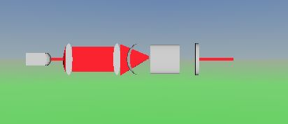
Figure1: Laser diode end-pumped Nd:YVO₄
- METHODOLOGY
Methodology involves developing a mathematical model of all the power equations and designing VR simulations. The VR software used in this work is virtual reality modeling language builder 2.0.The power equations are fed into mathematical software and a mathematical model is
developed. The mathematical model is then imported into the VR simulations. When the simulations are run, the equations in the mathematical model are triggered and output powers are calculated. The pump power values are applied on the cavity of Plano-concave through the VR modules. In this way photons are excited by applying pump power dynamically. Figure (1) shows sample diode-pumped Nd:YVO₄ use MATLAB as programming languages model .
- THEORETICAL MODEL
This section depicts the basic relationships such as laser output, threshold pump intensity and slope efficiency and internal system and material parameters using a space- dependent rate equation analysis which can be expressed by [3,4]:
  - Pth , Pout and ηs in terms of internal system parameters:
P_{th}=$\frac{Is}{ηs}\frac{γ2}{2}$_{πw} (1)
P_{out=Is}$\frac{γ2}{2}$ _{πwo}² [($\frac{Pp}{Pth})-1]$ (2)
$η_{s}=\frac{γ_{2}}{2γ}η=\frac{T}{δ+T} η$ (3)
Where γ₂ is the logarithmic loss of the output coupler of reflectivity R2 and Is is the saturation intensity.
  - Photon Lifetime
The photon lifetime (or the time constant of the cavity)refers to the average time that a photon spends in the cavity of a laser before passing through the output coupler (OC) and becoming part of the output beam or being absorbed in the lasing medium itself. Consider a given mode of a stable or unstable cavity and assume there are also some losses other than diffraction losses. For instance one may have mirror losses which results in mirror reflectivity being always smaller than unity. Let R1 and R2 be the (power) reflectivities of the HR & OC mirrors respectively and S the fractional internal loss per pass due to diffraction and any other internal loss, then the photon lifetime is given by [3]:
$t_{c }=\frac{round-trip distance through the cavity }{speed of light}×\frac{1}{logarithmic cavity loss}$
(4)
$$t_{c }=\frac{2L}{c\ln\left[1/{R_{1}R_{2}} {\left(1-S\right)}^{2}\right]}=-\frac{2L}{c\ln\left[R_{1}R_{2}{\left(1-s\right)}^{2}\right]}$$
(5)
- SIMULATION SET-UP
The schematic set-up of the plano-concave resonator is illustrated in figure (2). It is consists of the driver unit, the laser head, which contains the pump source was employed in this work is diode-laser. It delivered a maximum output power of (1 W) at the wavelength of 808 nm. The pump beam was focused into the laser crystal with a spot radius of about 0.2 mm by special focusing optical system (collimator f=8mm and focusing lens f=60mm). The mirror M1 was a concave mirror with radius of curvature of 200 mm, antireflection (AR) coated at 808 nm on the flat face, high-reflectance (HR) coated at 1.064μm, and high transmittance (HT) coated at 808 nm on the curved face. The laser crystal was a-cut, AR coated at 808 nm and 1.064μm on both of its faces, and placed closely to M1. The fundamental mode radius in the laser crystal was 0.184 mm. which has simulated emission cross section (15.6×10⁻¹⁹cm²) and spontaneous fluorescence lifetime (98μs). The plano-concave resonator a 3×3×2mm³, 0.3 at.% Nd:YVO₄ crystal have cavity length was 100 mm and the output couplers M2 were flat mirrors with different transmissions at 1.064μm of 5%, 10%, and 20% ,using this mirror with a plane mirror to complete the optical resonator. To remove the heat generated from the crystal, it was wrapped with indium foil and held in copper blocks, which were cooled by thermoelectric coolers [5].
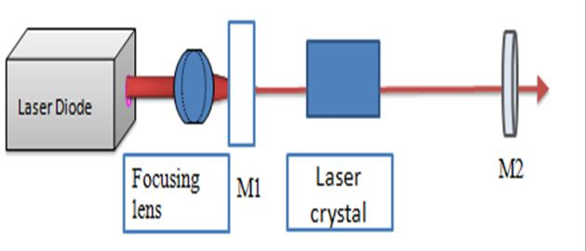
Figure 2: Schematic of the laser experimental setup
- BUILDING THE MODEL
The first step of building VR world is the basic building, in this step should be discussed two general principle which used to create virtual world which provide basic building blocks for easy object construction [6]:
Geometry: - from figure (3), the simple state refers to the primitive objects that are made available in V-Realm. Sphere, Cone , Cylinder, and Box. These simple objects can be changed in size, color, texture, position, and any other ways.

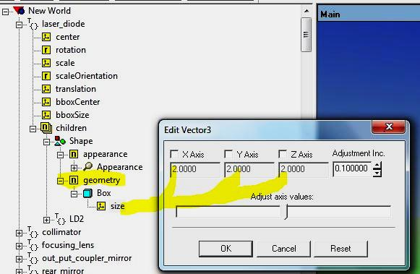
Figure 3: The geometry
Appearance:- From figure (4) we can see that shape ,image texture, material, front style ,movie texture, pix texture, texture transform and color all of these are the VRML nodes that allow as change some of the appearance characteristics of geometry whether primitive or not.
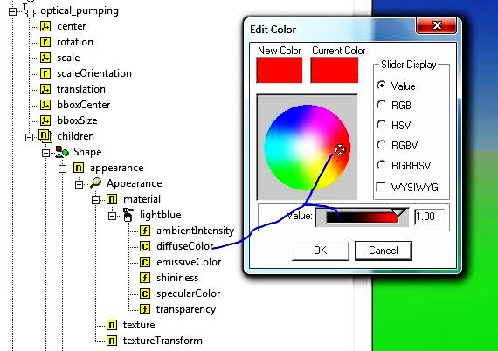
Figure 4: The appearance
For diode-pumped solid-state lasers utilization MATLAB (as programming languages), the model must be transformed into one of this programming languages. This is realized in our case using transformer program. Polygon Transformer (Poly Trans) is a software which converts each aspect of a 3-D model into polygons, as illustrated in figure (5), includes all texture mapping information, texture mapping coordinates, (for selective converters) animation data, and shading parameters. The figure (5) illustrates the texture mapped onto each of the laser rod and resonator. Where the laser atoms are created with variable frequencies and amplitudes, a user of the simulation can determination the frequency and amplitude of the atoms motion that would excite the laser system. As a result, one can virtually differentiate different atoms waves during the virtual scene.
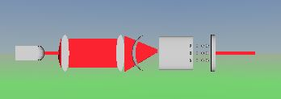
Figure 5: Virtual configuration of the laser system
- ANIMATION MODEL
To generate the data necessary to animate the ship and cargo for both the uncontrolled and controlled scenarios, we solved the equations of motion using the techniques mentioned in theoretical model. In order to read the data from the output files, the files must be opened and read line by line in the main body of the MATLAB code. After each line is read, the direct 3D display function is called upon to start a new frame; a high frame rate will cause the animation of the model. There is another way to show the data code is Open GL, this approach is useful in the field design because the correct transformation coordinate.
- RELATIONSHIP OF P_{TH} WITH OVERLAP EFFICIENCY AND OUTPUT COUPLER REFLECTIVITY
Figure (7) shows the relation between η_{B} and P_{th} for different values of output coupler reflectivities (R) for Nd:YVO₄ laser at fixed values of transfer efficiency (η_{T}=98%) and laser optical losses (L=0.08 cm⁻¹). This relation show that the decrease of P_{th} with increasing (R) values. On the other hand the increase of η_{B} beside the increase of (R) leads to additional decreasing in P_{th} values.
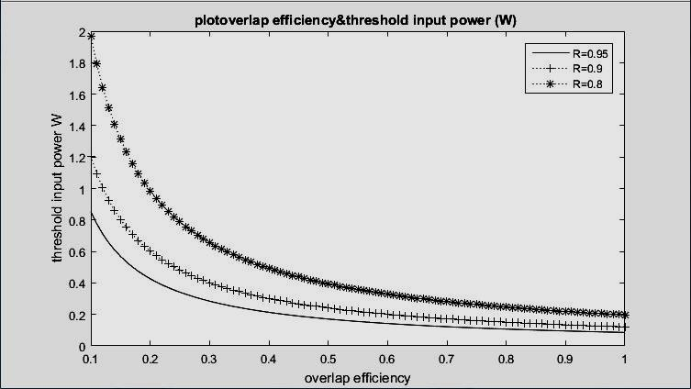
- RELATIONSHIP BETWEEN P_{TH} WITH (-ln(R))
Figure (8) shows the relation between P_{th} and natural logarithm of the output coupler reflectivity for"Nd:YVO₄" solid-state laser materials at fixed values of optical losses (L=0.08 cm⁻¹) and overlap efficiency (η_{B}=100%) and transfer efficiency (η_{T}=98%). Usually this relation can be used in calculating the internal resonator losses, from the extension line for linear relation, and take the value of its intersection with the axis of (ln(R)).
- RELATIONSHIP BETWEEN P_{OUT} AND P_{IN} WITH OUTPUT COUPLING
Figure (9) shows the CW output power at 1.064μm as a function of the incident pump power. This relations show that the laser was optimized with the 5% transmission coupler in the whole range of incident pump power.
- Adding a Virtual Reality Toolbox Block
In this procedure simulates end-pumping of DPSSL and lets view it in a virtual world:
1- A Simulink model opens without a virtual reality toolbox block that connects the model to a virtual world by typing vrlaser system in the MATLAB commend window as shown in figure (10).

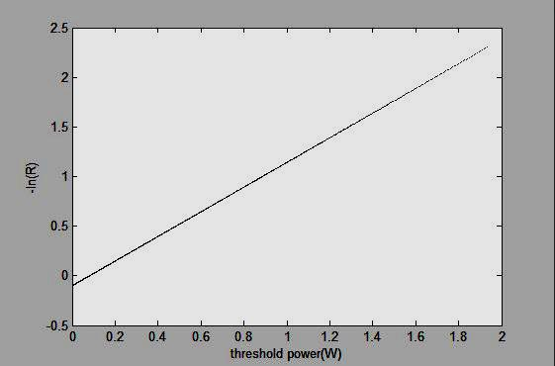
Figure 8: Input threshold power versus natural logarithmic output coupler reflectivity for Nd:YVO₄ laser

Figure7: Input power threshold versus overlap efficiency for
different values of output coupler reflectivity for Nd:YVO₄

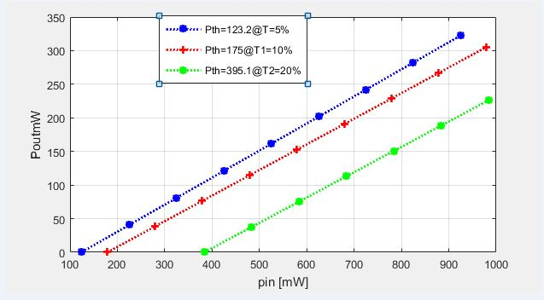
Figure 9: Nd:YVO₄ laser output power versus pump power
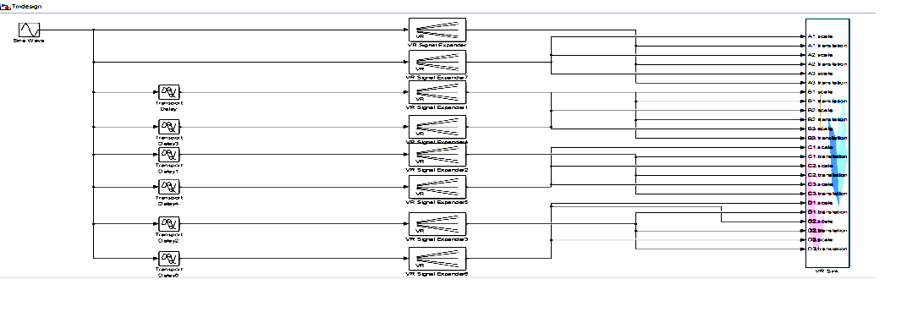
Figure10: Simulink model connected to the virtual reality toolbox and laser modeling
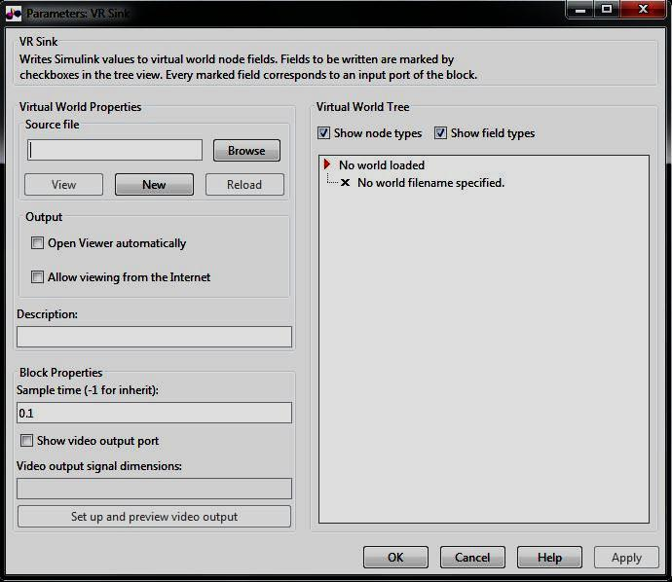
Figure11:Block parameters of the virtual reality Sink used to load the virtual world and selected the action which required to visualize their effect on the system

2- Dialog box opens by double clicking the block labeled VR sink.The block parameters: VR sink ,In the Simulink mode as shown in figure (11).
3- A brief description of the model can be entered and it will appear on the list of available worlds served by the virtual reality tool box server in the "Description" text box, for example, Type "VR of end-pump DPSSL Nd:YVO₄ system".
4-The select world dialog box opens by clicking the "Browser" button. Finding the directory <MATLAB>\toolbox\VR\ Nd:YVO₄ design VR. Selecting the file Nd:YVO₄ design.wrl, and clicking open.
5- A VRML tree appears on the right side, showing the structure of associated virtual reality scene. By clicking "apply" in the block parameters: "VR Sink" dialog box.
6-- By selecting show node types. And clicking the "+" square on the required node selected. The node tree expands. And it can be seen what the characteristics of the node can by driven from Simulink. In this model selecting translation and scale. This model computes the required effect on the system nodes tree as shown in figure (12).
7- Connect these input lines to the matching signals in the model. These signals were originally connected to scope blocks as shown in figure (13).
8- A viewer window containing the DPSSL system virtual world opens by double clicking "VR sink" block in the Simulink model. And Selecting the "view" button. As outlined in figures (14)

.
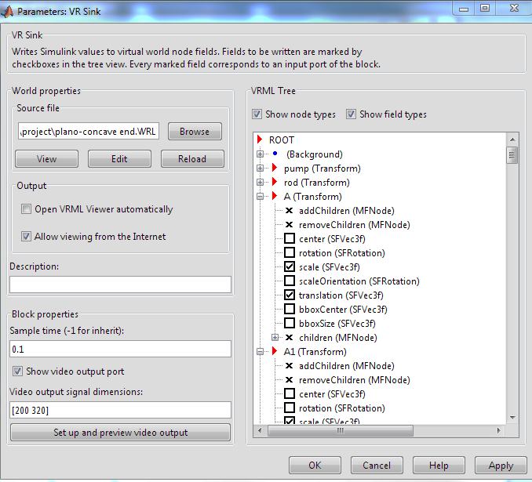
Figure 12: Block parameter of the virtual reality sink used to load the virtual world and selected the action which required visualizing their effect on the system
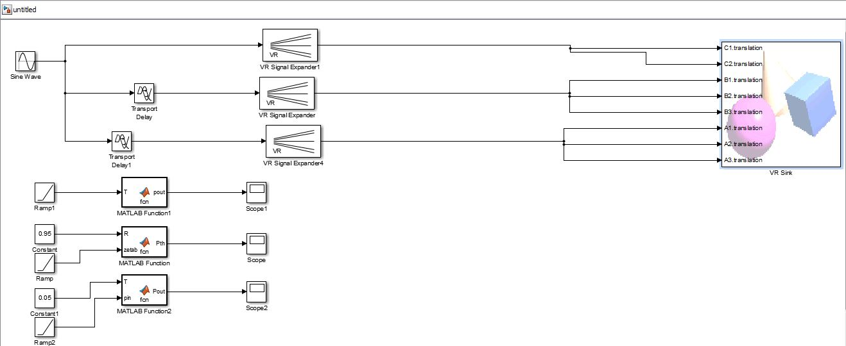
Figure13: simulink model connected to the virtual reality toolbox and laser modeling with appropriate vectors.
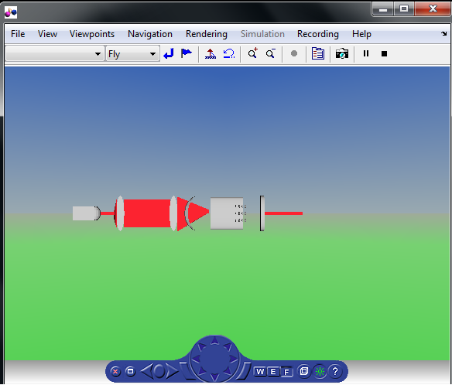
Figure 14: The Virtual diode end-pump Nd:YVO₄ laser system viewer open in the bluxxun window containing basic laser
resonator and diode pumping arrays

CONCLUSIONS
Our simulator serves as a multipurpose environment for many engineering applications in the area of diode-pumped solid-state laser systems. It provides a solid base and a good example of how engineering theories can be transformed into virtual reality applications. These provides a tool to prove and make them interesting as well as give better insight into engineering problems and their applications in the real life. The simulator is used to study the response of end diode-pumped Nd:YVO₄ laser systems. A deep visual understanding of such response is not possible experimentally because either the expense is too high or the experimental models are scaled to an extent where testing of these real scenarios may not give enough insight into the problem. As a result, and in order to adequately understand such models, researcher needs to expert a greater effort to be more experienced both theoretically and experimentally. These visualizations do convey useful information which is not currently available in 2-D model systems.

Bibliography
[1] Tamura Y., Kageyama A., Sato T., Fujiwara S. and Nakamura H., “Virtual Reality System To Visualize And Auralize Numerical Simulation Data”, Computer Physics Communications, 142, 227-230, (2001).
[2] L. Deligiannidis, And R. Jacob, “Using Constructions To Allow Parallel Processing In Multi-User Virtual Reality”, Ieee Computer Society, Proceedings Of The Ieee Virtual Reality 2003 (Vr’2003), 2003.
[3] Walter Koechner, (2006)Solid-State Laser Engineering, Sixth Revised and Updated Edition Springer Verlag.
[4] Xiong, Z. G. Li, N. Moore, W. L. Huang, and G. C. Lim, “Detailed investigation of thermal effect in longitudinally diode-pumped Nd:YVO4 lasers”, IEEE J.Quantum Electronic, Vol.39, pp979-986(2003).
[5] Mohammed. J. ,Hisham .M and Abdulla. K " Performance Analysis of Laser Diode Single-End-Pumped Solid State Laser" Journal(2013),. Vol.(21).
[6] Raaed k." design Implementation and Performance Analysis of Virtual Laser Control System ",PHD thesis ,(2006).
[7] M. Pendlebury “3d Virtual Reality Reconstruction On The Internet Using Vrml”, M.Sc Thesis, Manchester Metropolitan University, 2000.

